Stage 4 – Make A Difference
Designed by John Royer / Kyle Narkum
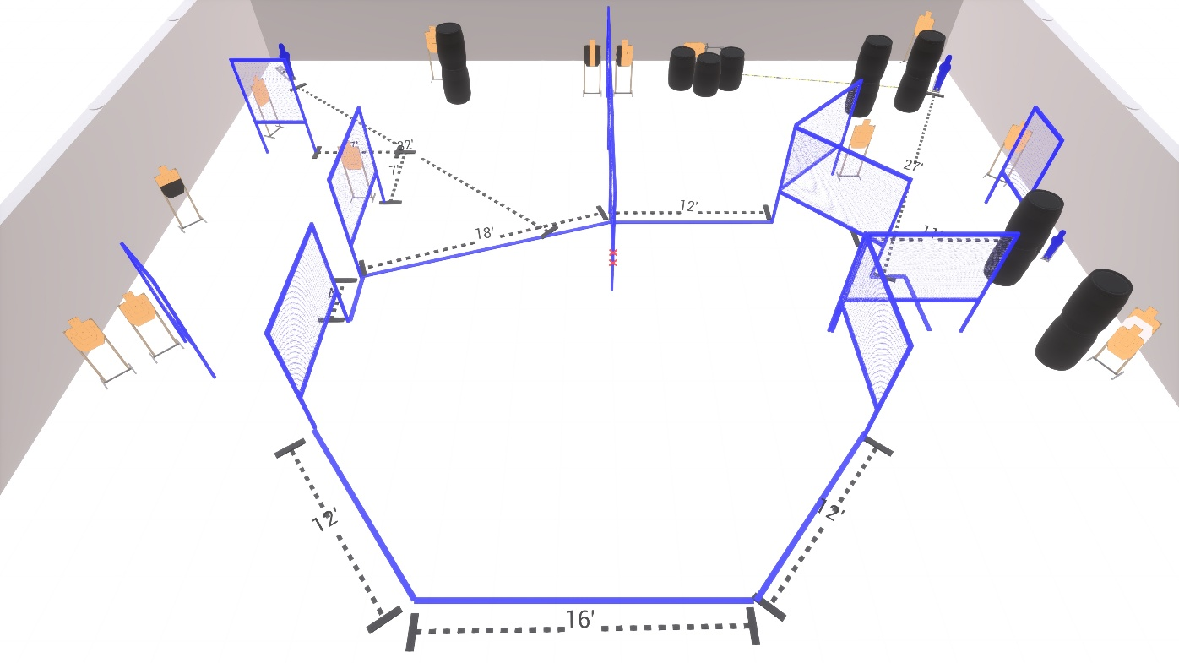
Welcome to Stage 4 - Make A Difference
I am _____________________________, the CRO for this stage and working with me are ____________________________________________________________.
Stage 4 is a 30 round Comstock course with 14 USPSA cardboard targets and 2 USPSA Poppers.
Start position is inside the shooting area.
Handgun loaded and holstered, hands touching marks.
PCC loaded, held in both hands, muzzle touching mark.
At the audible start signal, engage all targets as available from within the shooting area.
Swinger is activated by Popper 2 and remains visible at rest.
Are there any questions?
You have 4 minutes to walk the stage.

